Cognitive Approach

Pre attention

When you look at something, before analysing the thing, your brain has already think something about it

Photo 1:

* Your brain and eyes focus straight on the different one:
  + the smallest one (different size)
  + orientation
  + shape different
  + empty space
  + color
  + close points has more importance, they have a bigger relationship than points or group of points spaced

Building the theory:

* point: there no direction, you focus on the point but it doesn’t create an action
* line: your eye follow something, there a direction
* List:
  + it’s one of the most ancient visualization with have from history
  + the point is to have element that belong in the same group, stretch by ideas
  + it’s the most effective way the display item (usualy without any order)
  + eyes effect
    - for normal list that have the same size at each line => your eyes focus more on the first and last one

Petition round robin to counter this effect:

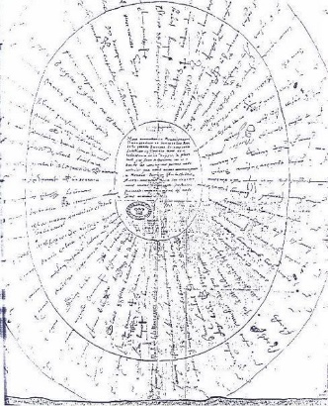

* + - if a line is longer or bigger than the other you focus more on this one